 

# Distributed Computing (Last Minute Revision)

**Chapter 1: Fundamentals**

***N******Department:*** *Computer Engineering*

***College:*** *Vidyalankar Institute of Technology*



**

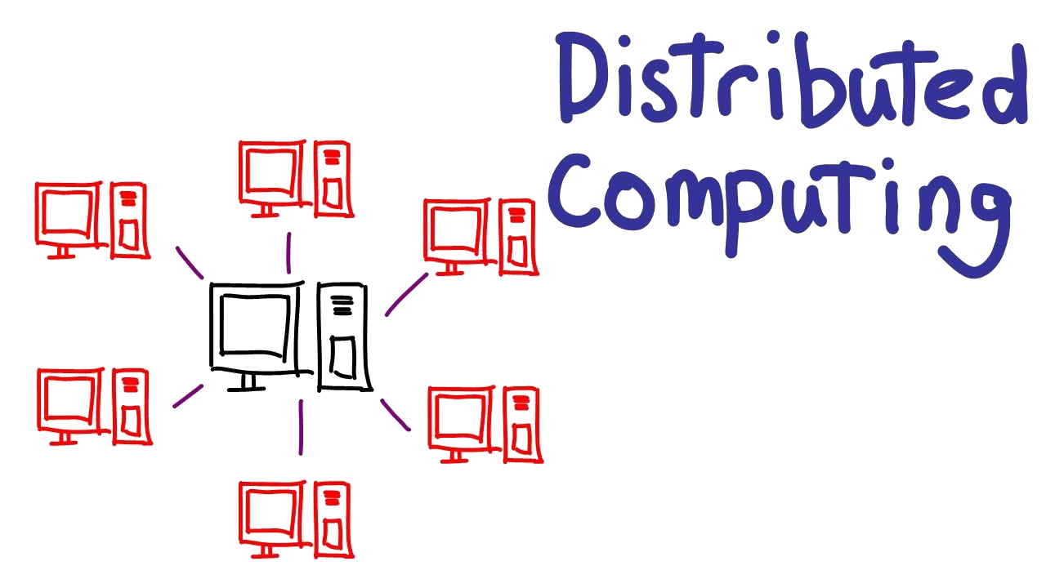

A *distributed system*, also known as distributed computing, is a system with multiple components located on different machines that communicate and coordinate actions in order to appear as a single *coherent system* to the end-user



# Distributed computing components

## Hardware

* **Tightly Coupled**
* **Loosely Coupled**

## Software

* **DOS**
* **NOS**
* **Middleware**





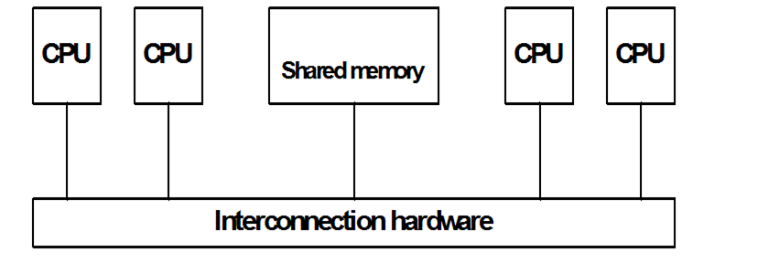

# Tightly Coupled



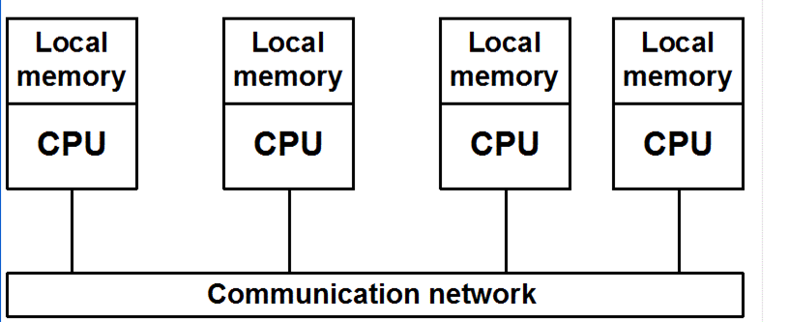

# Loosely Coupled

Prepared by Prof. Amit K. Nerurkar

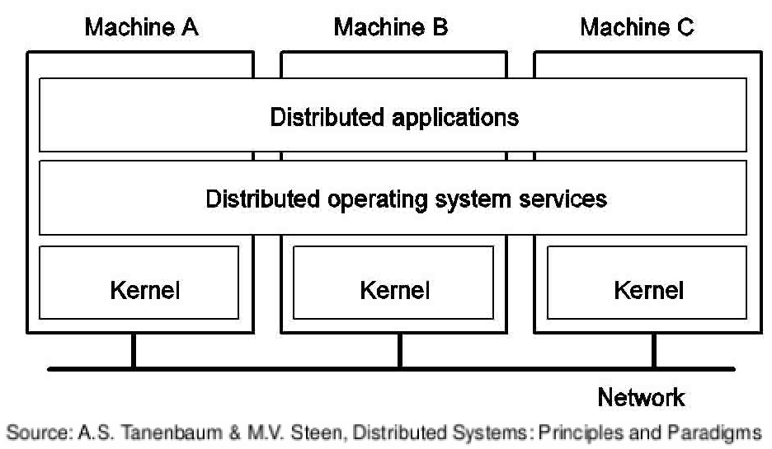 

# DOS



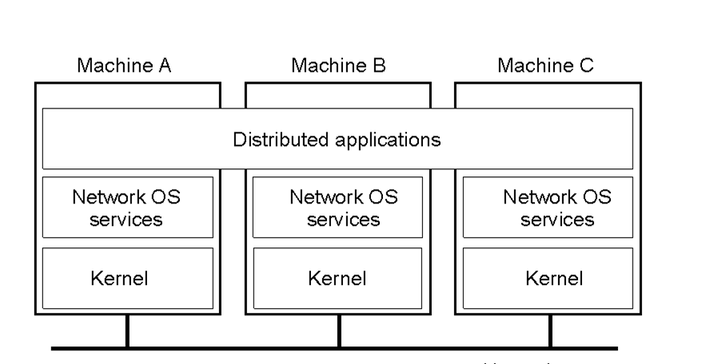

# NOS

 

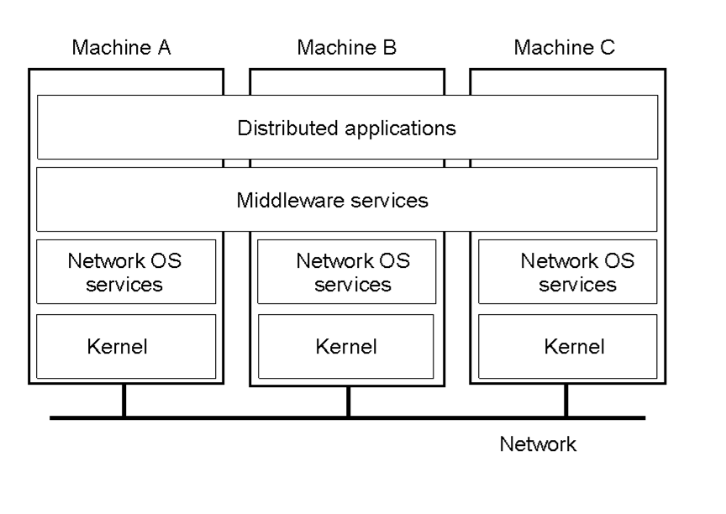

# DCE

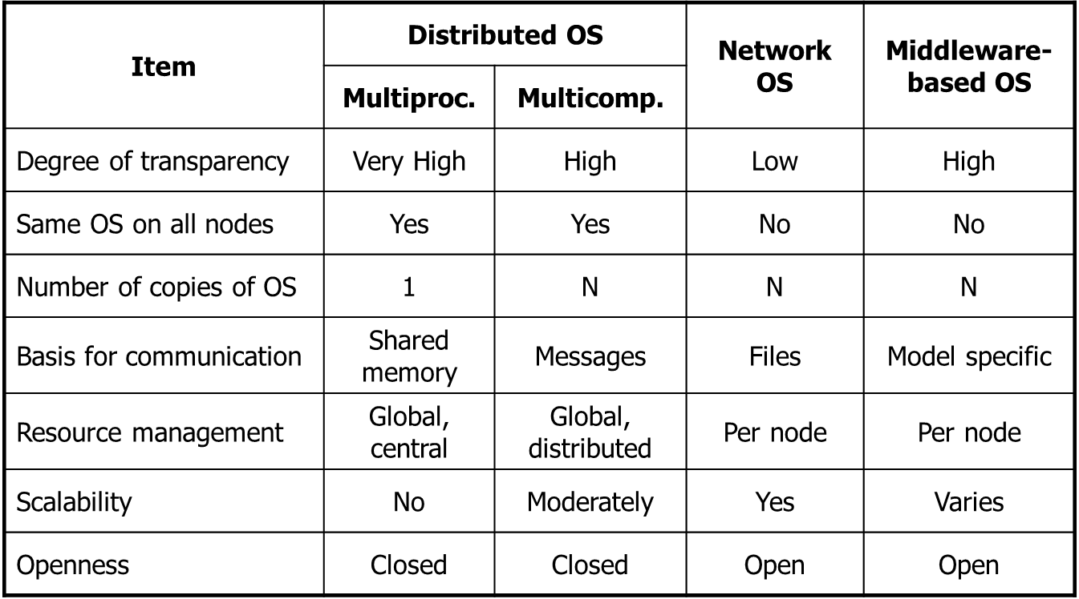 

# DOS vs NOS vs DCE

Prepared by Prof. Amit K. Nerurkar

# Goals of Distributed Systems

* Inherently Developed Applications
* High performance
* Low response time
* Scalability
* Flexibility
* Reliability
* Availability
* Security
* Better price performance ratio







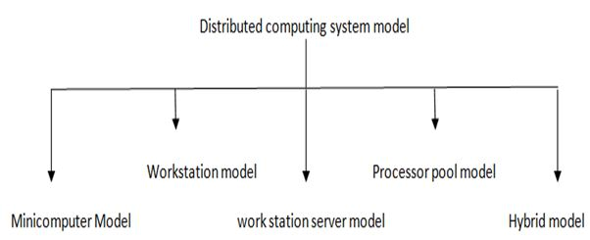

Prepared by Prof. Amit K. Nerurkar



# Mini Computer

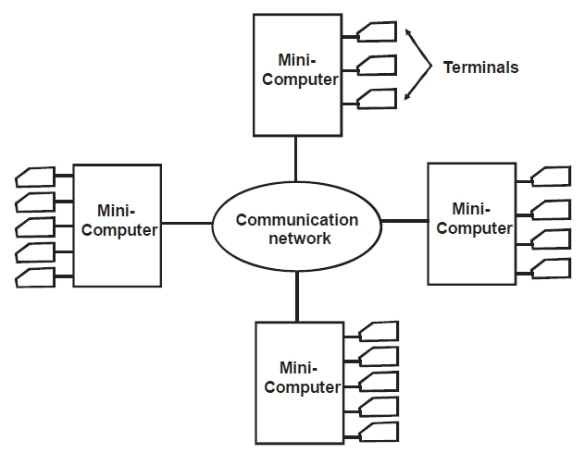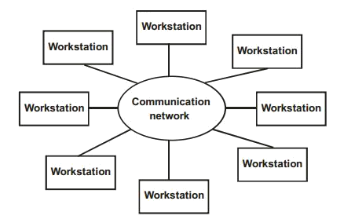

# Workstation

Prepared by Prof. Amit K. Nerurka



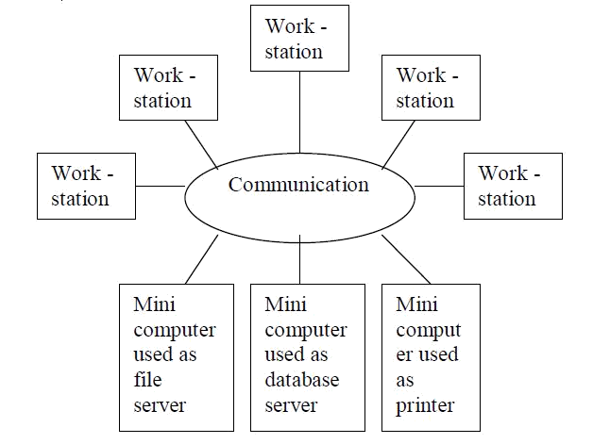

# Workstation Server

Prepared by Prof. Amit K. Nerurkar



# Processor Pool

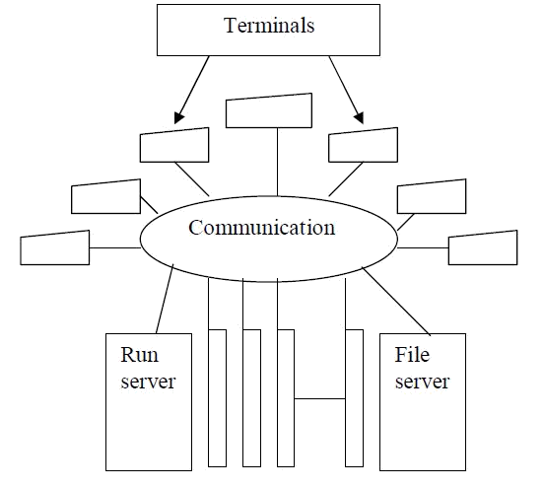





**Hybrid**

Combination of Workstation server and processor pool

**VIDYALANKAR INSTITUTE OF TECHNOLOGY (LMR OF DISTRIBUTED COMPUTING)**



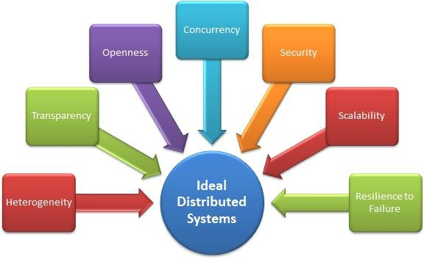

# Design Issues



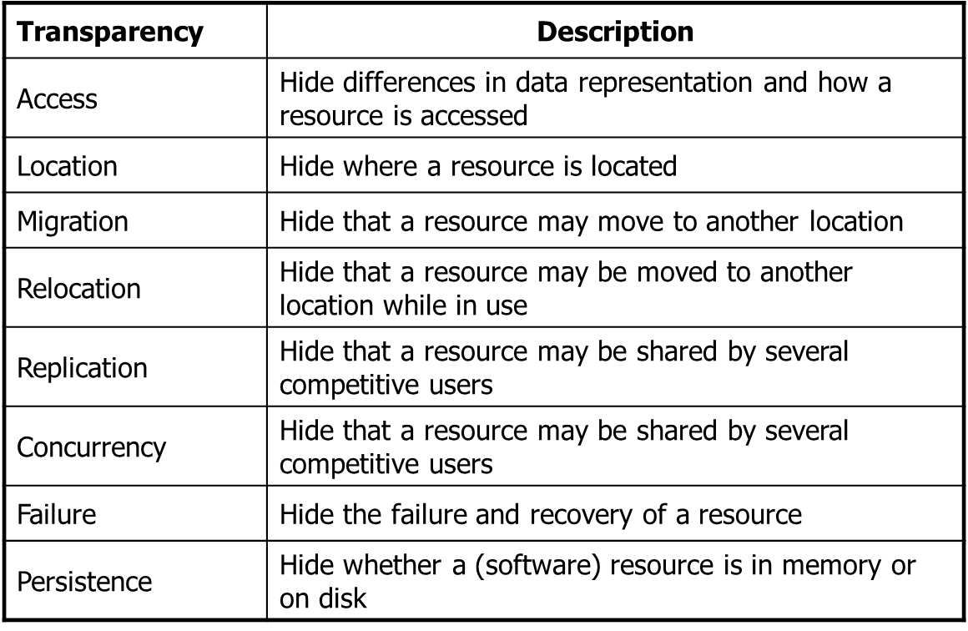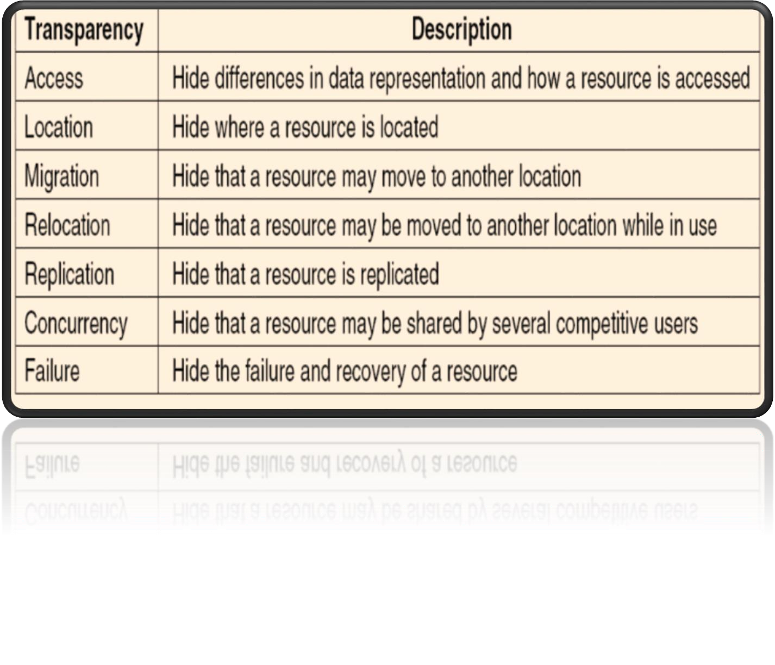

**Transparency**

* **FUNDAMENTALS**
* **Definition**
* **Components**
  + **Hardware**
    - **Tightly Coupled**
    - **Loosely Coupled**
  + **Software**
    - **DOS**
    - **NOS**
    - **Middleware**
* **Goals**
* **Models**
* **Design Issues**
* **Transparency**

# Final Summary

